

NATIONAL POLICE COMMISSION

**PHILIPPINE NATIONAL POLICE, POLICE REGIONAL OFFICE CALABARZON**

**CAVITE POLICE PROVINCIAL OFFICE**

**CARMONA MUNICIPAL POLICE STATION**

J.M. Loyola Street, Brgy. Maduya, Carmona, Cavite

May 2022

2022-05-208

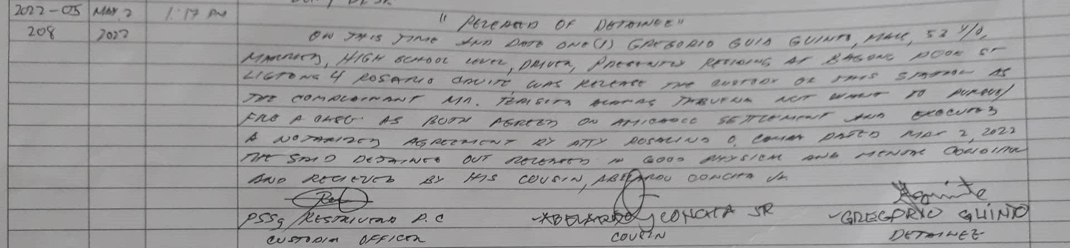

2022-05-209

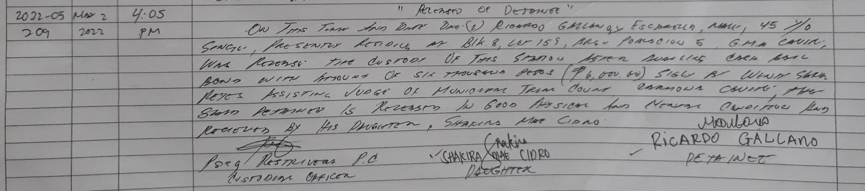

2022-05-210

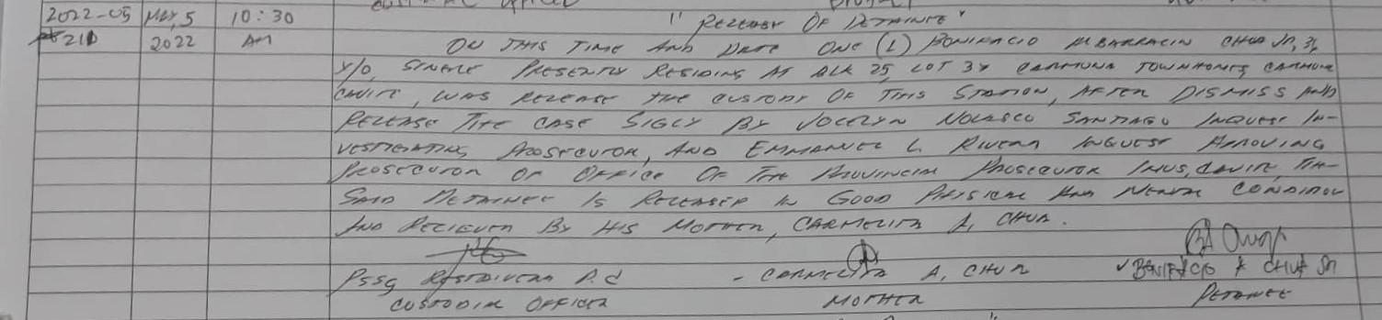

2022-05-211

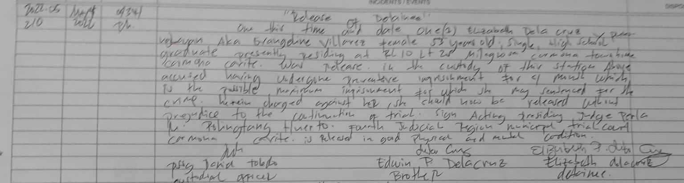

2022-05-212

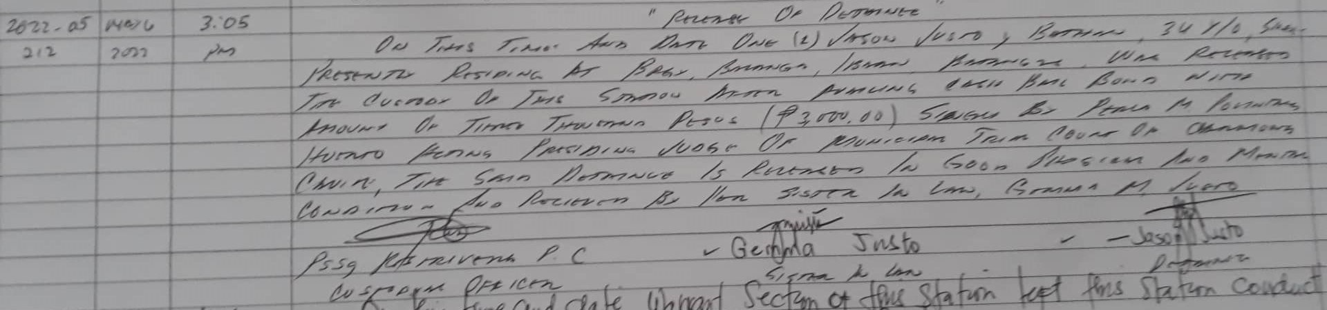

2022-05-215

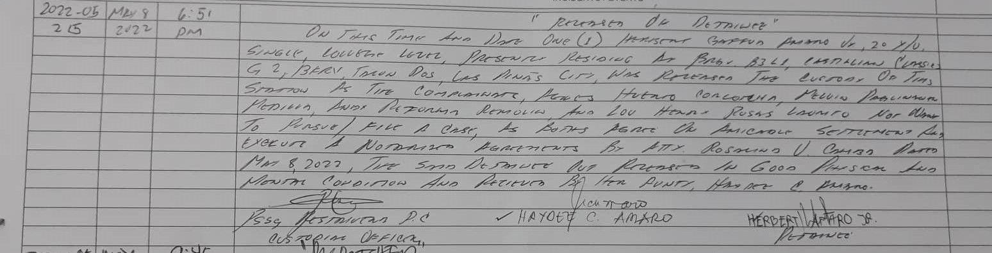

2022-05-229

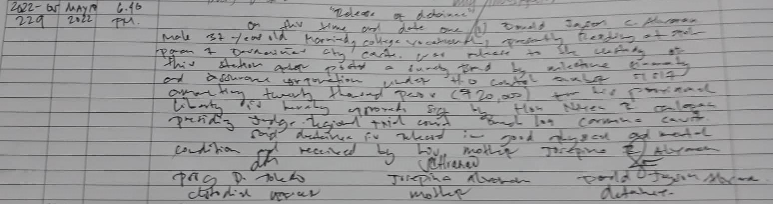

2022-05-235

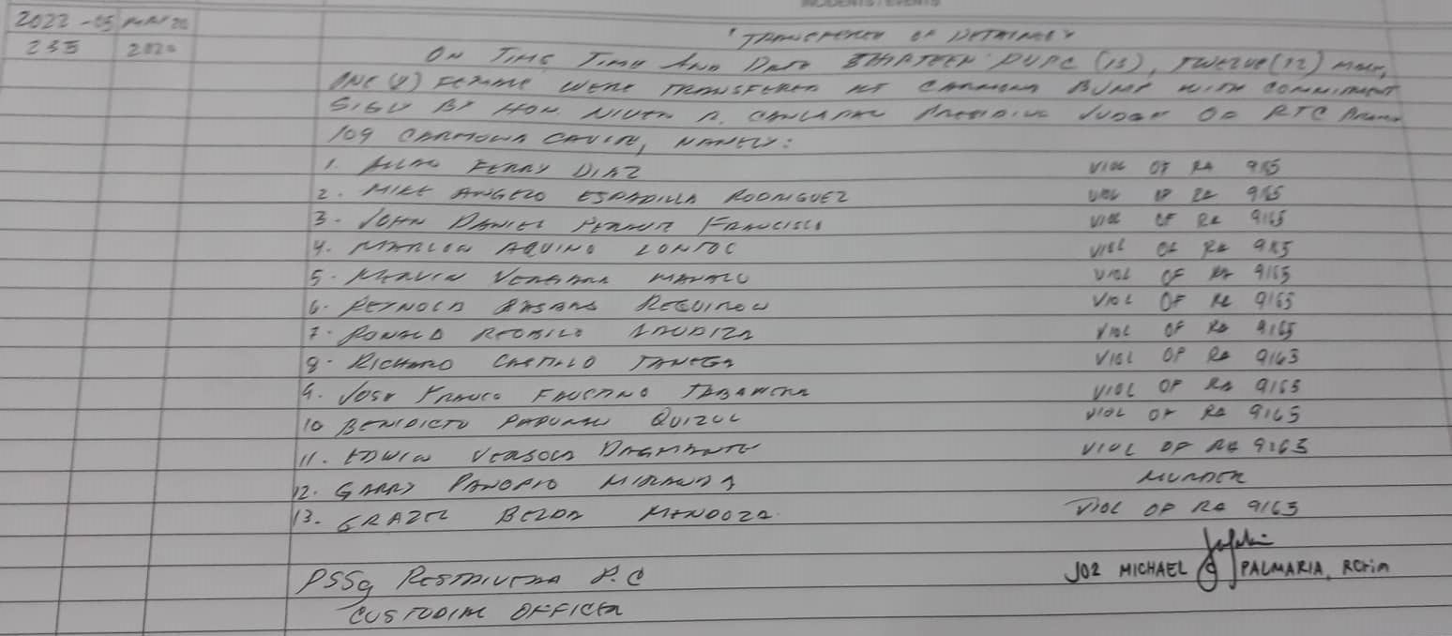

2022-05-243

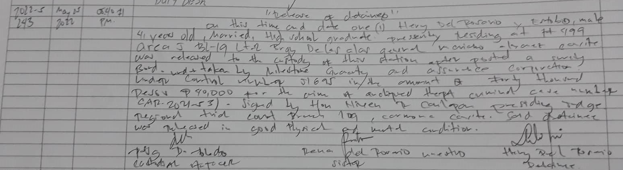

2022-05-244

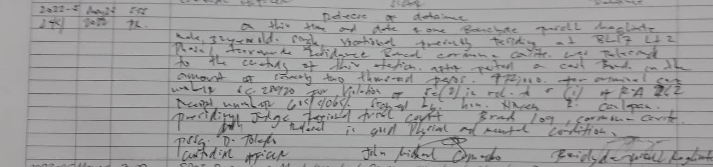

2022-05-246

